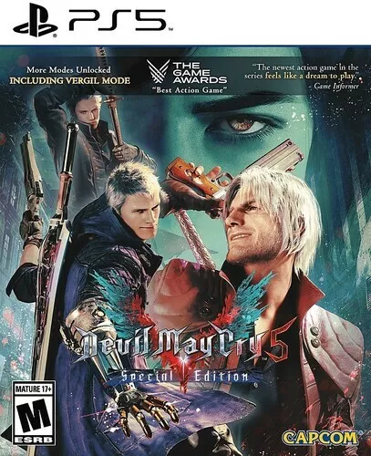

*Devil May Cry 5:*

1️. **Three Playable Characters with Unique Combat Styles**

* **Nero:** Uses powerful **Devil Breakers** (robotic arms) for various combat abilities.
* **Dante:** A versatile fighter with multiple weapons and **Devil Trigger** transformations.

2️. **Stylish & Fast-Paced Combat System**

* **Combo-based gameplay** with rankings from **D to SSS**.
* **Switch between weapons & abilities mid-fight** for creative combos.

3️. **New Devil Breaker System (For Nero)**

* Different **mechanical arms** grant unique abilities like **time-slowing, explosive attacks, and powerful grabs**.

4️. **Epic Boss Fights & Cinematic Storytelling**

* Features **intense, large-scale battles** against demons and legendary foes like **Urizen and Vergil**.5️⃣ **Special Edition Enhancements (PS5 & Xbox Series X/S)**
* **Playable Vergil** with his **Yamato sword & Beowulf gauntlets**.

5. **Special Edition Enhancements (PS5 & Xbox Series X/S)**

* **Playable Vergil** with his **Yamato sword & Beowulf gauntlets**.
* **Legendary Dark Knight Mode** (hordes of enemies for extra challenge).